

**Blink LEDs on Atmega 16**

Embedded Systems

Laboratory work 1

Done by: EKSfmu-16 gr. st. Arūnas Butkus

Checked by: doc. dr. Andrius Ušinskas

**Work goal:** Develop software for blink of 2 leds in 1000 ms and 500 ms..

Algorithms used in tasks.

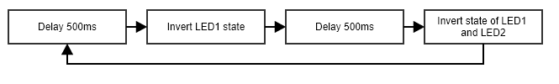

**Fig. 1.** “Algorithm”.

Results analysis.

Big whoop! LEDs blink. Another in the series: here’s a task – figure out how to use all this software and hardware. And LEDs blink. No animations in PDF.So the only lasting proof is clutter in my PC including useless stuff for my future like avrdude and such. Did harder code, also with the dude thing, for bachelor degree.

Conclusions.

LEDs blink.

Source code.

Magical code that magically disappeared and I’m in no mood to hunt for it.

Electrical schemes:

